 | Marwadi University  Faculty of Engineering & Technology  Department of Information and Communication Technology
Subject: Digital Signal and Image Processing (01CT1513) | Aim: Simulate discrete time sequences.
Experiment No: 1 | Date: 17/07/2026 | Enrollment No: 92400133104
EXPERIMENT-1

AIM: Simulate Discrete time Sequences

To plot unit impulse signal using Python.
In signal processing, a unit impulse signal, also known as a Dirac delta function or impulse
function, is a mathematical function that has the value of 1 at time zero and zero elsewhere.
Generating a unit impulse signal in Python can be done using the NumPy library.
Steps:
- First, we import the necessary libraries: numpy for numerical computations and matplotlib.pyplot for plotting.
- Next, we define a function called unit_impulse that takes two arguments: length (the length of the signal) and position (the position of the impulse within the signal).
- Inside the unit_impulse function, we create an array of zeros with the specified length using np.zeros(length).
- We set the value at the specified position to 1, representing the impulse.
- We define the parameters start, stop, and step to specify the x-axis range and step size.
- We use np.arange to generate the x-axis values. The np.arange function creates an array of numbers from start to stop (inclusive) with a step size of step.
- We calculate the length of the impulse signal using len(x), which represents the number of x-axis values.
- We modify the unit_impulse function call to calculate the position of the impulse based on the x-axis range. Since we want the impulse at n=0, we set the position to abs(start)//step, which calculates the index of 0 in the x-axis array.
- abs(start): The abs() function returns the absolute value of the start variable. This is done to ensure that the result is always positive, regardless of whether start is positive or negative.
- abs(start)//step: The // operator performs integer division, which discards the decimal part of the division result and returns the integer quotient. In this case, abs(start)//step calculates the number of steps from the start value to reach the position of 0 in the xaxis array.
- The unit_impulse function returns the generated signal.
- By using abs(start)//step as the position argument in the unit_impulse function call, we ensure that the impulse is correctly positioned at n=0 within the generated unit impulse signal.
- For example, if start = -10 and step = 1, the expression abs(start)//step evaluates to (10)//(1), which equals 10. This means that the impulse will be placed at index 10 in the signal, aligning it with n=0.
- Using abs(start)//step allows the code to handle both positive and negative start values correctly, ensuring that the unit impulse is positioned accurately regardless of the specified x-axis range and step size.
- We then define the desired length and position for the unit impulse signal.
- We generate the unit impulse signal by calling the unit_impulse function with the specified parameters.
- Finally, we plot the unit impulse signal using plt.stem to create a stem plot, and then display the plot using plt.show().
- When you run this code, it will generate a stem plot showing the unit impulse signal with a spike at the specified position (in this case, position 10).
- plt.grid(True) in the code helps to improve the visual representation of the plot by adding gridlines, making it easier to analyze.
- Note: To run this code, you'll need to have the NumPy and Matplotlib libraries installed. You can install them using pip install numpy matplotlib.

Program :
import numpy as np
import matplotlib.pyplot as plt

def unit_impulse(length, position):
signal = np.zeros(length)
signal[position]=1
return signal

start = -10
stop = 10
step = 1

x = np.arange(start, stop+step, step)
impulse_signal = unit_impulse(len(x), abs(start)//step)

plt.stem(x, impulse_signal)
plt.xlabel('Time')
plt.ylabel('Amplitude')
plt.title('Unit Impulse Signal')
plt.grid(True)
plt.show()

Output :
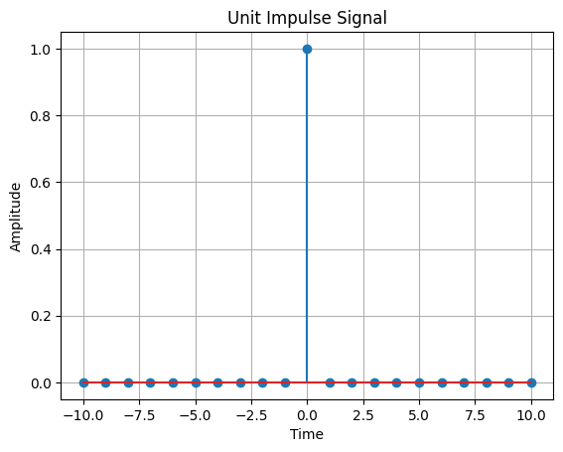
AIM: Simulate impulse train Theory:
An impulse train, also known as a Dirac comb, is a periodic sequence of impulses. Each impulse has an amplitude of 1 and occurs at regular intervals. The impulse train is often used in signal processing to model periodic phenomena or to analyze the frequency response of systems.

The impulse train is defined as follows: impulse_train(n, period) = 1, if n % period == 0
= 0, otherwise
where n is the sample index and period is the period of the impulse train.

Flowchart:
The flowchart for the program will consist of the following steps:

Define the parameters for the impulse train: signal length and period.
Create an empty array to store the impulse train.
Iterate over each sample index.
Check if the sample index is a multiple of the period. If yes, assign the value 1 to the impulse train array at that index; otherwise, assign the value 0.
Plot and display the impulse train.
Save the impulse train array (optional).
Now, let's see the Python program that simulates an impulse train:

Program :

import numpy as np
import matplotlib.pyplot as plt

def impulse_train(length, period):
x = np.zeros(length)

for i in range(length):
if i % period == 0:
x[i] = 1
return x

signal_length = 100
period = 10

plt.stem(impulse_train(signal_length, period))
plt.xlabel('Sample')
plt.ylabel('Amplitude')
plt.title('Impulse Train Signal')
plt.grid(True)
plt.show()

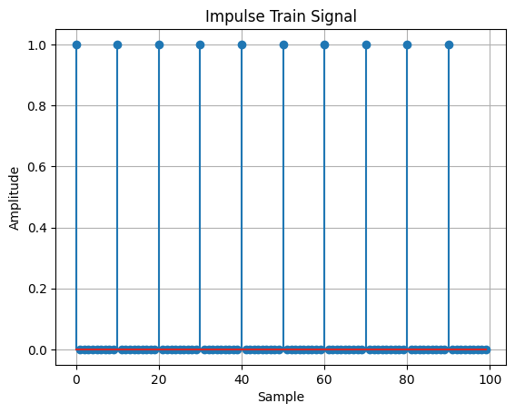

AIM: Write a python program to Simulate continuous and discrete unit step signal,

Theory:
A unit step signal, also known as a Heaviside step function, is a signal that is 0 for negative time or indices and 1 for non-negative time or indices. It is commonly used to represent a sudden change or transition in a system.

The continuous unit step function is defined as:
u(t) = 0, t < 0
= 1, t >= 0
The discrete unit step function is defined as: u[n] = 0, n < 0 = 1, n >= 0

Flowchart:
The flowchart for the program will consist of the following steps:

Define the time range (for the continuous signal) or the number of samples (for the discrete signal).
Create an empty array to store the unit step signal.
Iterate over each time or sample index.
Set the value of the unit step signal to 0 for negative time or indices, and 1 for non-negative time or indices.
Plot and display the unit step signal.
Save the unit step signal array (optional).
Now, let's see the Python program that simulates continuous and discrete unit step signals:

Program :

import numpy as np
import matplotlib.pyplot as plt

def simulate_continuous_unit_step(time):
unit_step = np.zeros_like(time)
unit_step[time >= 0] = 1
return unit_step

def simulate_discrete_unit_step(num_samples):
unit_step = np.zeros(num_samples)
unit_step[num_samples // 2:] = 1
return unit_step

time = np.linspace(-5, 5, 1000)
continuous_unit_step = simulate_continuous_unit_step(time)

num_samples = 20
discrete_unit_step = simulate_discrete_unit_step(num_samples)

plt.figure(figsize=(8, 6))

plt.subplot(2, 1, 1)
plt.plot(time, continuous_unit_step, linewidth=2)
plt.title('Continuous Unit Step Signal')
plt.xlabel('Time')
plt.ylabel('Amplitude')
plt.grid(True)

plt.subplot(2, 1, 2)
plt.stem(range(num_samples), discrete_unit_step)
plt.title('Discrete Unit Step Signal')
plt.xlabel('Sample')
plt.ylabel('Amplitude')
plt.grid(True)

plt.tight_layout()
plt.show()

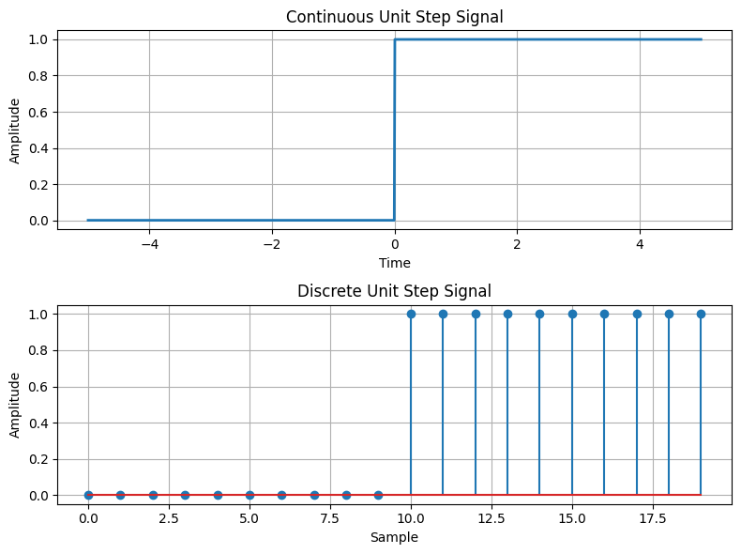

AIM: Write a python program to Simulate continuous and discrete ramp signal,

Theory:
A ramp signal is a signal that varies linearly with time. It starts at an initial value and increases or decreases at a constant rate. Ramp signals are commonly used in various applications, such as signal processing, control systems, and digital communications.

The continuous ramp signal is defined as:
ramp(t) = a * t, for t >= 0
= 0, for t < 0 where a is the slope of the ramp.

The discrete ramp signal is defined as:
ramp[n] = a * n, for n >= 0 = 0, for n < 0 where a is the slope of the ramp.

Flowchart:
The flowchart for the program will consist of the following steps:

Define the time range (for the continuous signal) or the number of samples (for the discrete signal).
Create an empty array to store the ramp signal.
Iterate over each time or sample index.
Set the value of the ramp signal to a * t for continuous or a * n for discrete, where a is the slope and t or n is the time or sample index.
Plot and display the ramp signal.
Save the ramp signal array (optional).
Now, let's see the Python program that simulates continuous and discrete ramp signals:

Program:

import numpy as np
import matplotlib.pyplot as plt

def simulate_continuous_ramp(time, slope):
ramp = np.zeros_like(time)
ramp[time >= 0] = slope * time[time >= 0]
return ramp

def simulate_discrete_ramp(num_samples, slope):
ramp = np.zeros(num_samples)
ramp[num_samples // 2:] = slope * np.arange(num_samples // 2)
return ramp

time = np.linspace(-5, 5, 1000)
num_samples = 20
slope = 2

continuous_ramp = simulate_continuous_ramp(time, slope)
discrete_ramp = simulate_discrete_ramp(num_samples, slope)

plt.figure(figsize=(8, 6))

plt.subplot(2, 1, 1)
plt.plot(time, continuous_ramp, linewidth=2)
plt.title('Continuous Ramp Signal')
plt.xlabel('Time')
plt.ylabel('Amplitude')
plt.grid(True)

plt.subplot(2, 1, 2)
plt.stem(range(num_samples), discrete_ramp)
plt.title('Discrete Ramp Signal')
plt.xlabel('Sample')
plt.ylabel('Amplitude')
plt.grid(True)

plt.tight_layout()

plt.show()

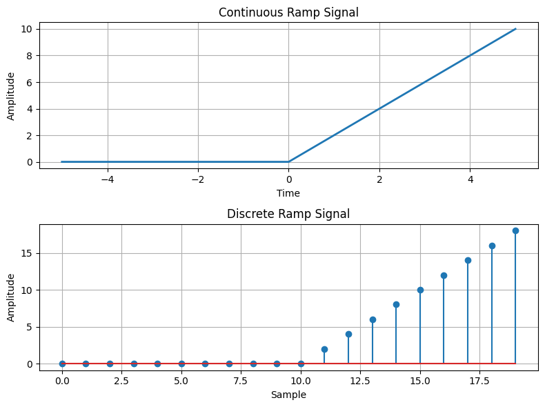
AIM: Write a python program to Simulate continuous and discrete exponential signal, Theory:
An exponential signal is a signal whose amplitude changes exponentially with time or index. Exponential signals can exhibit either growth or decay behavior, depending on the sign of the exponential term.

The continuous exponential signal is defined as: x(t) = A * exp(b * t) where A is the initial amplitude, b is the exponential coefficient, and t is the time.

The discrete exponential signal is defined as:
x[n] = A * exp(b * n) where A is the initial amplitude, b is the exponential coefficient, and n is the sample index.

Flowchart:
The flowchart for the program will consist of the following steps:

Define the time range (for the continuous signal) or the number of samples (for the discrete signal).
Create an empty array to store the exponential signal.
Iterate over each time or sample index.
Set the value of the exponential signal to A * exp(b * t) for continuous or A * exp(b * n) for discrete, where A is the initial amplitude, b is the exponential coefficient, and t or n is the time or sample index.
Plot and display the exponential signal.
Save the exponential signal array (optional).
Now, let's see the Python program that simulates continuous and discrete exponential signals:

Program :

import numpy as np
import matplotlib.pyplot as plt

def simulate_continuous_exponential(time, amplitude, coefficient):
exponential_signal = amplitude * np.exp(coefficient * time)
return exponential_signal

def simulate_discrete_exponential(num_samples, amplitude, coefficient):
exponential_signal = amplitude * np.exp(coefficient * np.arange(num_samples))
return exponential_signal

time = np.linspace(-5, 5, 1000)
num_samples = 20
amplitude = 1
coefficient = -0.5

continuous_exponential = simulate_continuous_exponential(time, amplitude, coefficient)
discrete_exponential = simulate_discrete_exponential(num_samples, amplitude, coefficient)

plt.figure(figsize=(8, 6))

plt.subplot(2, 1, 1)
plt.plot(time, continuous_exponential, linewidth=2)
plt.title('Continuous Exponential Signal')
plt.xlabel('Time')
plt.ylabel('Amplitude')
plt.grid(True)

plt.subplot(2, 1, 2)
plt.stem(range(num_samples), discrete_exponential)
plt.title('Discrete Exponential Signal')
plt.xlabel('Sample')
plt.ylabel('Amplitude')
plt.grid(True)

plt.tight_layout()

plt.show()

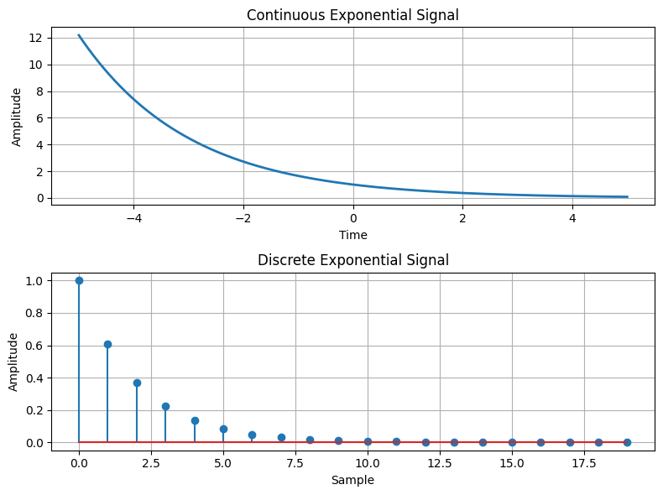
AIM: Write a python program to Simulate continuous and discrete parabolic signal

Theory:
A parabolic signal is a signal whose amplitude changes quadratically with time or index. It follows a parabolic curve and is commonly used to model various phenomena, such as projectile motion, signal processing, and data fitting.

The continuous parabolic signal is defined as: parabolic(t) = a * t^2 + b * t + c where a, b, and c are coefficients and t is the time.

The discrete parabolic signal is defined as:
parabolic[n] = a * n^2 + b * n + c where a, b, and c are coefficients and n is the sample index.

Flowchart:
The flowchart for the program will consist of the following steps:

Define the time range (for the continuous signal) or the number of samples (for the discrete signal).
Create an empty array to store the parabolic signal.
Iterate over each time or sample index.
Set the value of the parabolic signal to a * t^2 + b * t + c for continuous or a * n^2 + b * n + c for discrete, where a, b, and c are the coefficients and t or n is the time or sample index.
Plot and display the parabolic signal.
Save the parabolic signal array (optional).
Now, let's see the Python program that simulates continuous and discrete parabolic signals:

Program :

import numpy as np
import matplotlib.pyplot as plt

def simulate_continuous_parabolic(time, coefficients):
parabolic_signal = np.polyval(coefficients, time)
return parabolic_signal

def simulate_discrete_parabolic(num_samples, coefficients):
parabolic_signal = np.polyval(coefficients, np.arange(num_samples))
return parabolic_signal

time = np.linspace(-5, 5, 1000)
num_samples = 20
coefficients = [1, 2, 1]

continuous_parabolic = simulate_continuous_parabolic(time, coefficients)
discrete_parabolic = simulate_discrete_parabolic(num_samples, coefficients)

plt.figure(figsize=(8, 6))

plt.subplot(2, 1, 1)
plt.plot(time, continuous_parabolic, linewidth=2)
plt.title('Continuous Parabolic Signal')
plt.xlabel('Time')
plt.ylabel('Amplitude')
plt.grid(True)

plt.subplot(2, 1, 2)
plt.stem(range(num_samples), discrete_parabolic)
plt.title('Discrete Parabolic Signal')
plt.xlabel('Sample')
plt.ylabel('Amplitude')
plt.grid(True)

plt.tight_layout()

plt.show()

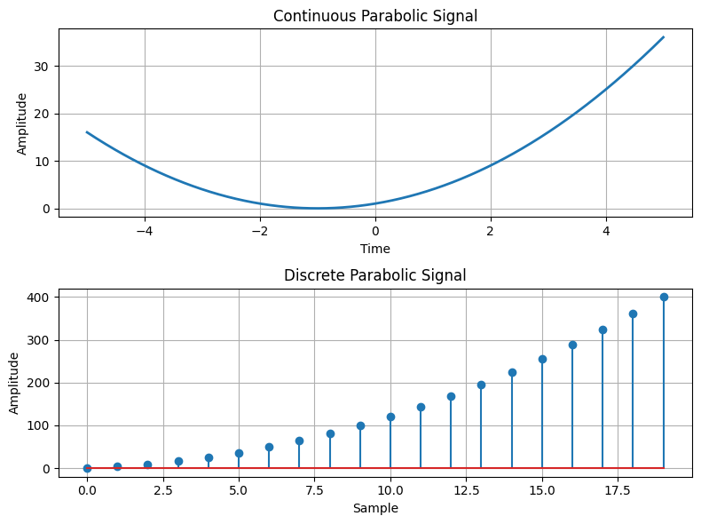

AIM: Write a python program to Simulate continuous and discrete sine wave signal

Theory:
A sine wave signal is a continuous-time or discrete-time signal that follows a periodic oscillation described by the sine function. It is widely used in various applications, such as signal processing, communications, and audio synthesis.
The continuous sine wave signal is defined as:
sine(t) = A * sin(2 * pi * f * t + phi) where A is the amplitude, f is the frequency, t is the time, and phi is the phase.

The discrete sine wave signal is defined as: sine[n] = A * sin(2 * pi * f * n / Fs + phi) where A is the amplitude, f is the frequency, n is the sample index, Fs is the sampling frequency, and phi is the phase.

Flowchart:
The flowchart for the program will consist of the following steps:

Define the time range (for the continuous signal) or the number of samples and the sampling frequency (for the discrete signal).
Create an empty array to store the sine wave signal.
Iterate over each time or sample index.
Set the value of the sine wave signal to A * sin(2 * pi * f * t + phi) for continuous or A * sin(2 * pi * f * n / Fs + phi) for discrete, where A, f, t, n, Fs, and phi are the corresponding parameters.
Plot and display the sine wave signal.
Save the sine wave signal array (optional).
Now, let's see the Python program that simulates continuous and discrete sine wave signals:

Program :

import numpy as np
import matplotlib.pyplot as plt

def simulate_continuous_sine_wave(time, amplitude, frequency, phase):
sine_wave = amplitude * np.sin(2 * np.pi * frequency * time + phase)
return sine_wave

def simulate_discrete_sine_wave(num_samples, sampling_frequency, amplitude, frequency, phase):
time = np.arange(num_samples) / sampling_frequency
sine_wave = amplitude * np.sin(2 * np.pi * frequency * time + phase)
return sine_wave

num_samples = 100
sampling_frequency = 100
frequency = 2
amplitude = 1
phase = 0

time = np.linspace(0, 1, 1000)

continuous_sine_wave = simulate_continuous_sine_wave(time, amplitude, frequency, phase)
discrete_sine_wave = simulate_discrete_sine_wave(
num_samples, sampling_frequency, amplitude, frequency, phase
)

plt.figure(figsize=(8, 6))

plt.subplot(2, 1, 1)
plt.plot(time, continuous_sine_wave, linewidth=2)
plt.title('Continuous Sine Wave Signal')
plt.xlabel('Time (s)')
plt.ylabel('Amplitude')
plt.grid(True)

plt.subplot(2, 1, 2)
plt.stem(range(num_samples), discrete_sine_wave)
plt.title('Discrete Sine Wave Signal')
plt.xlabel('Sample')
plt.ylabel('Amplitude')
plt.grid(True)

plt.tight_layout()

plt.show()
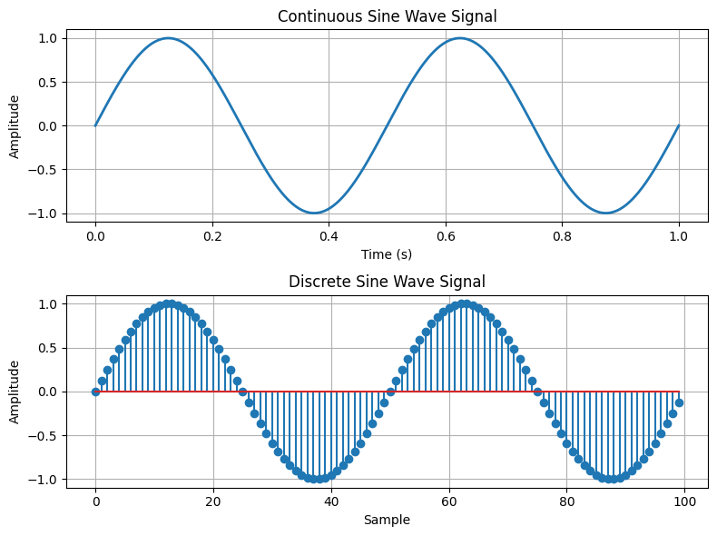

AIM: Write a python program to simulate y(t)=u(t)+u(t-1)+3u(t+5).
Theory:
The unit step function, denoted as u(t), is a function that is 0 for negative time or indices and 1 for non-negative time or indices. It is commonly used to represent a sudden change or transition in a system.

The function y(t) = u(t) + u(t-1) + 3*u(t+5) is a combination of three unit step functions. It has a value of 1 at t=0, t=1, and t=-5, and a value of 0 elsewhere.

Flowchart:
The flowchart for the program will consist of the following steps:

Define the time range.
Create an empty array to store the function values.
Iterate over each time index.
Calculate the value of y(t) at each time index using the given function formula. Plot and display the function values.

import numpy as np
import matplotlib.pyplot as plt

def simulate_function(time):
y = np.zeros_like(time)
y[time >= 0] = 1
y[time >= 1] += 1
y[time >= -5] += 3
return y

time = np.linspace(-10, 10, 1000)

function_values = simulate_function(time)

plt.figure(figsize=(8, 4))
plt.plot(time, function_values, linewidth=2)
plt.title('Function y(t) = u(t) + u(t-1) + 3u(t+5)')
plt.xlabel('Time')
plt.ylabel('Amplitude')
plt.ylim(-0.5, 5.5)
plt.grid(True)
plt.show()

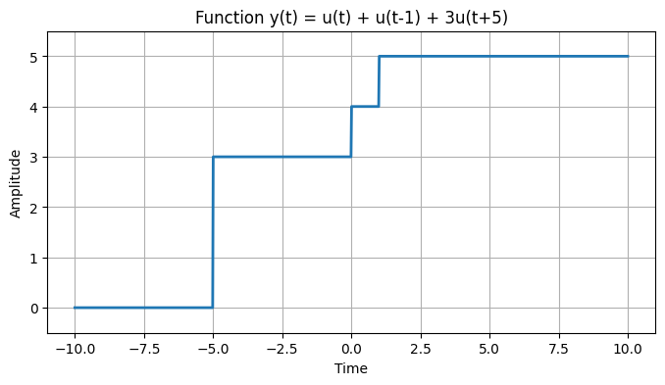

AIM: Write a python program to simulate y(t)=Delta(t)+delta(t-1)+3*delta(t+5).
Theory:
The impulse function, denoted as Delta(t), is a function that is infinite at t=0 and zero elsewhere. It is often used to model instantaneous events.

The shifted impulse function, denoted as delta(t), is similar to the impulse function but is shifted by a certain amount. It is non-zero only at the shifted time.

The function y(t) = Delta(t) + delta(t-1) + 3*delta(t+5) is a combination of three impulse functions. It has an impulse at t=0, t=1, and t=-5, with different magnitudes.

Flowchart:
The flowchart for the program will consist of the following steps:

Define the time range.
Create an empty array to store the function values.
Iterate over each time index.
Calculate the value of y(t) at each time index using the given function formula.
Plot and display the function values.
Now, let's see the Python program that simulates y(t) = Delta(t) + delta(t-1) + 3*delta(t+5):

Program :

import numpy as np
import matplotlib.pyplot as plt

def simulate_function(time):
y = np.zeros_like(time)
y[time == 0] = 1
y[time == 1] += 1
y[time == -5] += 3
return y

time = np.arange(-10, 11)

function_values = simulate_function(time)

plt.figure(figsize=(8, 4))
plt.stem(time, function_values)
plt.title('Function y(t) = δ(t) + δ(t-1) + 3δ(t+5)')
plt.xlabel('Time')
plt.ylabel('Amplitude')
plt.ylim(-0.5, 4.5)
plt.grid(True)
plt.show()

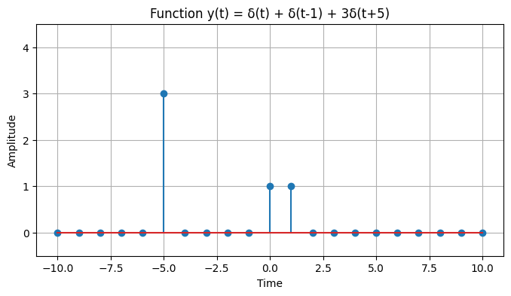

Conclusion :

The experiments were successfully performed to simulate and analyze various continuous-time and discrete-time signals using Python. Signals such as the unit impulse, impulse train, unit step, ramp, exponential, parabolic, sine wave, and combinations of shifted unit step and impulse functions were generated and visualized using NumPy and Matplotlib. These simulations helped in understanding the mathematical representation, characteristics, and behavior of fundamental signals used in Digital Signal Processing (DSP). The practical implementation also improved familiarity with Python programming for signal generation and graphical analysis, reinforcing the theoretical concepts of discrete-time and continuous-time signal processing.

